

System Information Manual

Ver 2.2

02th May, 2001

Table of Contents

1. Adding a new User 3
1.1 Adding a user to Windows NT Server 3
1.2 Adding a user to SQLBase 4
2. Configuring a New Computer 4
2.1 Mapping the Drives 5
2.2 Installing SQLBase Client 5
2.3 Databases 10
2.4 Computer Settings 10
3. Printing 10
3.1 Print Servers 11
4. Troubleshooting 12
4.1 Scheduler 12
4.2 Invoices 12
4.3 Reprinting Invoices 12
5. Network 14
5.1 Workstation Network Configuration: 14
5.2 Macs 15
6. Internet and Email 16
6.1 ISP Settings 16
6.2 Web Page 18
6.3 Faxing 18
7. Anti-virus 18
7.1 Updating virus recognition files 19
7.2 Updating VET database engine 19
8. Backup 19
9. Security 20
10. Watering Database 24
11. Tips and Tricks 20
11.1 Printer Drivers 20
11.2 Finding the OS Product Key 20
12. SQL Reporting 20
12.1 Using SQLTalk 22

Information about the Fleming’s IT System can be found in FlemingsITInformation.xls in the Assistant Network Administrator’s Folder somewhere!

The Fleming’s System consists of network application and file servers running NT4.0 (SP6a) with approximately twenty-five IBM clone “workstations” running Windows 95, 98 or 2000 Operating Systems. Workstations obtain their IP addresses via DHCP, which runs on the machine called NTServer. Printing services include IBM/Lexmark and HP laser printers, and a number of high-speed dot-matrix printers.

The Graphics department consists of two Apple Macs with associated high quality colour printers and scanner generally not accessible to other users.

Email software used is MS Outlook 2000 or Outlook Express with an Intel email Station acting as a server. It connects to the ISP periodically (currently every 5 minutes) through an Intel Internet Station (router) to send and receive email. The Internet Station allows multiple users to access the Internet (albeit at reduced speeds – currently 48K even with 56K modems – this is a line problem and not a modem or hardware problem).

Other software includes an in-house database (written in Centura), Word, Excel, VET anti-virus, Internet Explorer, Acrobat Reader and the White Pages on CD. Not all users use all software.

All users have a personal folder held on the server that is backed up on a nightly basis, as is the Stock database.

Adding a new User

To add a new USER to the Fleming System you must have both:

- Administrator privileges for Windows NT 4.0 and
- DBA privileges for Centura SQLBase

Adding a user to Windows NT Server

First, click on the start button, go to the programs menu and select the “Administrative tools common,” then click the Administrative Wizard.
- From the option select “Add User accounts” and choose the domain name, “NTDOMAIN.”
- You are then required to enter the user details e.g.: Full name, Username and password.
- The new user must be set as a member to a group or groups. This gives the user their common access rights, depending on groups assigned to.
- You then have the option to set up a Profile, Login script and other options for the user including Restrictions. Set Logon Script to userlog.bat in order to have automatic virus updates and drive mapping done at user logon. Click Next.
- Assuming all details were entered correctly, click the Finish button and the users account will be created.
Every new USER should have a new folder created on the NT Server under:

- H:\USER\[NEWUSER] where NEWUSER is the name of the new user (!)
E.g. H:\USER\Graham

This new folder should be set as a shared folder, giving permissions to the user only (and Domain Administrators). All users’ folders are setup as hidden folders. To do this you must add a $ to the end of the Shared Name (e.g. Graham$). Hidden folders do not show on screen – however they are still available via direct access. (E.g. \\ntserver\graham$ will access the folder).

As part of the Backup procedure all subdirectories on H:\ are backed up automatically. Hence, when you add a new user their files will be backed up every night, without you having to change the Backup Program’s File list.

Adding a user to SQLBase

- From the desktop run the SQLtalk icon
- Open the file Add or Remove Users.sql (in the K:\Centura\Maintenance Procedures directory)
- Add the New User to “Grant Connect to [USERNAME] identified by [USERNAME];”
- Commit the changes
- Add the New User to “Grant All on [Various Programs etc.] TO [USERNAME LIST];“
- Commit the changes.

Configuring a New Computer
The following section outlines the settings required by each workstation. It also covers basic installation of the Centura and Fleming’s Systems on a new PC. The settings are the same for every workstation whether they are running Windows 95/98 or NT/2000.

Current Versions of software used as at the 10th Jan 2000:

All Users:
SQLBase Client 7.5.1, SQLBase Client 7.5.1-PTF2 (Upgrade)
Deployment files for CTD 1.5.1-PTF6
Word 97, Excel 97
Outlook Express 5.0, Internet Explorer 5.0
Acrobat Reader 4.0
VET Anti-virus software (installs automatically if the person logging on is a normal user. They will have a login script file on the server)
Some Users:
Team Developer 1.5
White Pages
Ami Pro
NOTES:
If you are installing Team Developer Ver 1.5, this must be installed prior to SQLBase.

TP_9 has a registered image viewer loaded called TIFFSURFER. Details are found in G:\APPS\TiffSurfer.

Mapping the Drives
A logon script automatically maps the correct drive letter to the network shares listed below, with the exception of the Z: drive (user home directory). Due to limitations with Windows 9x, this should be manually mapped for each user. Windows NT/2k users should have the correct mapping defined for the user directory via the User Manager profile. Right clicking on ‘My Computer’ will allow you to enter any other desired mappings.

Drive | Path | Used By
G:\ | \\P111SERVER\SYS | Various Programs
J:\ | \\P111SERVER\Vol1 | Some older USER files (AmiPro etc..)
K:\ | \\P111SERVER\Vol2 | SQLBase; all NTServer Files
M:\ | \\NTSERVER\Ian Mac Volume | Graphics Dept. Limited Permissions
X:\ | \\NTSERVER\Xfile | SQLBase Customer Filing System
W:\ | \\NTSERVER\WhitePages | Telstra White Pages CD
Z:\ | \\NTSERVER\[USERNAME$] | Current User’s Home Directory

After the Operating System has been installed the following programs need to be installed also.

- SQLBase Client 7.5.1
- SQLBase Client 7.5.1-PTF2 (Upgrade)
- CTD 1.5.1-PTF6 deployment files
- MSWord
- MSExcel
- Acrobat Reader
- Internet Explorer and Outlook Express (if they haven’t been loaded as part of the OS)

Installing SQLBase Client

Installing SQLBase

Run K:\Rebuilds\SQL Base 7.5.1 CD Key 8842\SQLBase Server\setup.exe

Welcome screen – Click Next

At the User information screen add the following details:
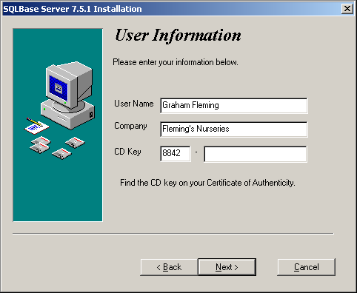

Select ‘Next’ and the ‘Yes’ to agree to the licence terms.
Use the default location Program Group as Centura\SQL Base 7.5.1 and choose ‘Next’.
The destination folder should remain as the default C:\Centura. Choose ‘Next’
---------------------------------------------
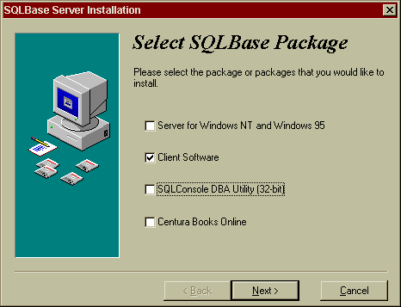
Select SQLBase Package screen - If you are installing SQLConsole (which provides administrative functions for the database etc) then choose SQLConsole Database Utility (32 bit) on the screen below otherwise just choose Client Software for a “normal user” (is there any such thing!?)

User Information screen (not shown here) - Enter Graham Fleming and Fleming’s Nurseries in the appropriate fields and 3512 in the License field. Keep pressing Next!

Ready To Install! screen - Choose Next

Select Components screen (below) - Choose the ticked items.
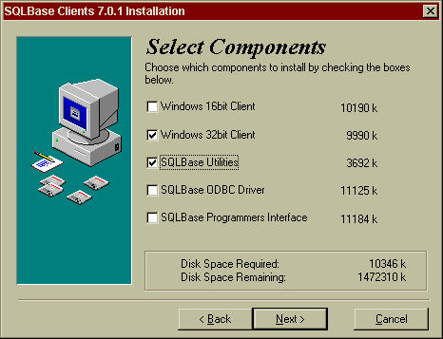

Novell NDS Installation screen (not shown here) - Select “NO”.
Select Destination Directory screen – this screen requires you to enter C:\Centura. Do so if it is not done already.
Select Program Group screen – Choose the default offered Centura SQLBase 7.0.1 Ready To Install screen – Go!

At the end the following screen appears. When it does - enable NetBIOS.
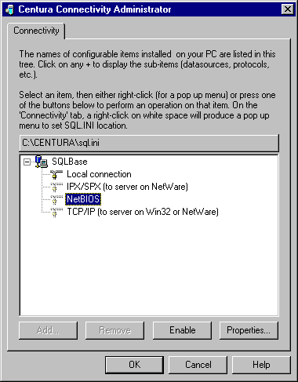
THEN:

Copy the following directories from a working client across the network:

C:\Centura – Localexe, Deploy, CSVs, Maintenance, Icons, Upgrades. (It may be easier just to grab the entire Centura directory and copy it from one machine to another. Make sure it’s just an “ordinary” user you are copying from and not a programmer or administrator’s computer. This will overwrite the sql.ini file but that only needs a minor change to be made to it. It’s probably easier than grabbing each of the directories individually.) Also – run the program UpdateRegistry.exe to alter structure (PD)

Upgrading SQLBase

Run C:\Centura\Upgrades\Client Sql Base 7.0.1 Ptf 2\setup.exe

Welcome screen

Please Select the Components to be patched screen –
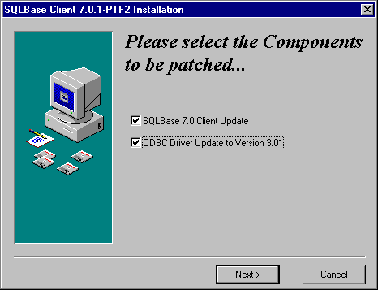

Select Destination Directory screen – C:\Centura is the acceptable default of course.
Installation Completed – Finish!

Deploying the Team Developer RunTime files

Run C:\Centura\Deploy\Deploy15.exe

Welcome! screen – Next
Select Destination Directory screen– C:\Centura as usual.
Ready To Install screen– Next!
Installation Completed screen!

Copy the Windows START directory in its entirety from another machine.

Install printers required (see FlemingsITInformation.xls for configuration and settings)

The intricacies of SQL.INI are beyond the scope of this book (I’ve always wanted to write that!) However, because you may have copied another machine’s sql.ini across you may have to open it up and change one line in it to point to your machine.

There are two ways to do this.

Way 1) In the section of sql.ini as shown below (towards the end of the file) you will find the following section for Win 95 and NT. At the end of that section the following lines appear…
[win32client]
clientname=TPG_P2_4 (or whatever).

You have to change it to the name of your computer - whatever it is - and save the file. That’s all.
; Win32 (Windows 95 or NT)
;--------------------------
etc
;
; comdll SQLBase target
; ------ --------------
; sqlapipe LOCAL database using Anonymous Pipes
; sqlntnbi REMOTE database using NetBios
; sqlws32 REMOTE database using TCP/IP (WinSock)
; sqlspx32 REMOTE database using IPX/SPX (Win32 Novell Client)
; sqlwsspx REMOTE database using IPX/SPX (Win32 Microsoft Client)
;
[win32client]
clientname=TPG_P2_4

Way 2) The other way is to open C:\WINDOWS\Start Menu\Programs\Centura\SQLBase 7.0.1\Connectivity Manager (send it to the desktop as a shortcut ‘cause you’ll probably need it a few times!) and in the SQLBase properties dialog box you can enter the clientname of your computer.

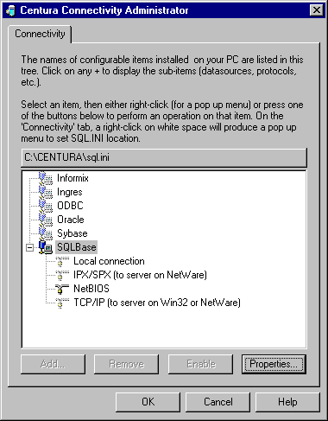
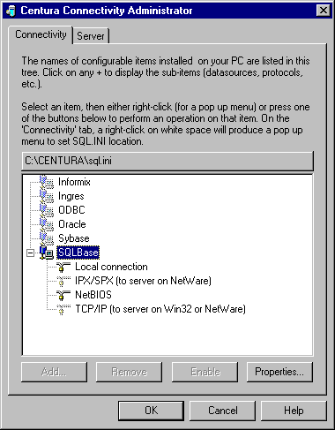
Screen Shot for Client-Only installation
Screen Shot for Client-Server installation

Databases
There are a number of databases to take into consideration:

Stock.dbs – the main Fleming’s database.
Stklocal.dbs – a copy of Stock.dbs held on the local hard drive for easy access when testing sql statements. This way dumb programmers don’t crash the main system so often. When they’ve finished testing then they can apply the statement to the main database.
Island.dbs – provided by SQLBase for training purposes
Stockdev.dbs – similar to Stklocal.dbs but held on the server
Creddev – an undeveloped database for the accounts department
Sqlcon.dbs – a database created by SQLConsole when you power it up.

The ones you work with most are Stock and Stklocal. There are two main Listening Protocols to set up and they are LOCAL (for island and stklocal on the hard drive if you have them) and NETBIOS for listening across the network. Protocols and databases can be enabled and disabled, added and subtracted etc. If you run SQLConsole then you have to add servers and databases in there via the Connection Manager as well.

SERVERS: Each database must have a server. The server for SQLBase on the network is DBNTSRV. On a local machine it can be anything. In the past we have named it SERVER1 (pretty creative eh!) (as you will see when you explore the depths of the Connectivity Manager. As before, those depths are not within the scope etc.

N.B. A program (MAINT.EXE) runs automatically when you exit the Fleming’s menu after it has been opened. To run it the first time you can grab it from K:\Centura\Flemlive.

A “snapshot” of the database is taken daily by a program originating on the administrator’s machine. Just before this occurs another program recalculates the stock inventory.

Computer Settings
In order to maintain consistency throughout the office each workstation should have identical settings where possible. Each individual may change their screen “look” (e.g. colours, wallpaper, screensaver etc), however, the Start Menu options should be consistent.

Printing

In the printers setup you will often find Paper Size written as A4. This size is actually 11” and is a legacy peculiarity of previous administrators! E.g. Epson DFX-8000 A4 is really Epson DFX-8000 11” ! A4 for laser printers is really and truly A4.

Print Servers

Intel NetPort Express XL

The NetPort Express services the main printer traffic.

The NetPort XL has three ports:

- Parallel LPT1 – Genicom
- Parallel LPT2 – Epson DFX-8000
- Serial – IBM 4234

Lantronix EPS2

The Lantronix EPS2 print server is currently being used for the printer in Christine’s Office and the General Office printer.

The Lantronix has three ports,

- Parallel EPS_0E36DD_P1
- Parallel EPS_0E36DD_P2
- Serial EPS_0E36DD_S1 (RJ-45 Connector)

Dlink DP300 ( x 2 )
The 2 D-Link 300s have three ports each (configured using telnet [IPAddress]):

- serves Barcode printer in sales area (retailps 192.168.42.17)
- serves Carpark printer in growers area (growerps 192.168.42.16)

Dlink DU-H3SP
The DU-H3SP is a 3 port USB hub

- 3 x USB “A type”
- 1 x USB “B type”
- 1 x Serial Port
- 1 x Parallel Port

Troubleshooting

Scheduler
The scheduler program runs when the first person in the morning logs on. Sometimes it can take a long time so be patient. If the scheduler crashes use the DBA’s (Graham’s) Machine to:

Access Centura Team Builder Program
Select TABLES ⇒ SCHEDULE ⇒
Delete all Rows EXCEPT two dates after today
UPDT WHEN AVAILABLE
UPDT DENORM FIELDS

Then use the FLEMINGS SYSTEM to re-invoice the customer.

This method will over-write the old INVOICE number and update TRANSACTIONS.

In Filing rename the incorrect (original) INVOICE with ERROR at the end.
i.e. C333404Y98INV065800282INVOICC10ERROR.CSV

Invoices

If the system crashes during invoicing follow this procedure. It may have incorrectly stored the INVOICE.

Check if the INVOICE prior to and in the middle of the CRASH is stored in the TRANSACTION table. If it is stored, then everything is OK.

If NOT, then check the INVOICE number in the CUSTOMER_ORDER table, it should exist.
Set:
- Invoiced_Flag = ‘N’,
- Invoiced_Date = null,
- Invoiced_By = null,
- COMMIT the changes

Reprinting Invoices

Sometimes people make errors (perish the thought!) especially the Sales staff. If they happen to print an invoice on the wrong printer or upside-down or whatever then you may be asked to reprint it. It’s very simple.

Open Report Builder 1.1
(C:\Centura\repbi11.exe)
Maximize screen if necessary.

Finding the Invoice Template:

When an invoice is misprinted you will usually find the associated CSV file for that customer on the computer from where it was printed – in e.g. \\Tpg_p2_5\c\Centura\CSVs\Invoices. Order the files by Date Modified and look for the customer number at the head of the file name and the invoice number following.

From the File Menu open the appropriate version of the Report Builder Invoice Template found at location “K:\Centura\Reports\Invoic[xx].qrp” (where [xx] refers to the version of the report template, e.g. Invoic11.qrp, Invoic12.qrp etc

The template version is obtained by looking at the end of the .CSV filename which you will use to link to it; e.g. C310406Y99INV32480012QINVOIC11.CSV. In this case the template will be Invoic11.qrp.

Linking the Customer Data with the Invoice Template:

The Invoice Template (e.g. Invoic12.qrp) will use information contained in a raw data file with a filename which has a .CSV extension
(e.g. C310406Y99INV32480012QINVOIC11.CSV etc)
This .CSV file can be found in the particular customer’s directory on the ‘X’ Drive.
(e.g. X:\Filing\Customers\[State]\[CustomerNumber] \Invoices\C310406Y99INV32480012QINVOIC11.CSV)

.CSV files with names such as 49710004.CSV contain the data for more than one Invoice.

[Note: CSV stands for Comma Separated Values and means that all the data for the report looks something like this (fields separated by commas) –
3210045,24/2/99,Jones,$24.95
2354656,25/2/99,Smith,$126.00 etc]

Previewing the Invoice:

Opening this .CSV file will LINK the customer data to the Template but you will not see any of this information until you choose Report – Preview from the Report Menu.

Printing the Invoice:

Load the correct printer with the correct paper.
Choose Printer Setup from the File Menu
Select the correct Name: (IBM 4234 Invoices)
Select the correct Paper Size: (US standard fanfold 14 7\8 x11
[the ‘11’ may be cut off and look like ‘1’ but ignore this]
Select the correct Paper Source: (Continuous - Page Break)
Ensure the correct Paper Orientation: (Portrait)

Select Print from the File Menu
Choose the Print range (default is All)
Click OK - A Report message may appear which says “Report page size exceeds printer page size… etc”
Choose No to print the Invoice
(You may Cancel the print at this stage but do not choose Yes)

Network

The Fleming’s Network is a Windows NT Server with approximately twenty five clients. This section outlines details about Windows NT, protocols, and peripherals.

Every workstation gets information from the Flemsys.ini file found in [K:\CENTURA\Flemings Registry Settings] Two “maintenance” programs – MAINT.EXE and UPDATEREGISTRY are used to keep the workstations up-to-date. They are called by the main Flemings Menu program when necessary.

Workstation Network Configuration:

- Client for Microsoft Networks (Log onto NTDOMAIN)
- Dialup Adapter
- Intel Network Adapter (various types – bound to TCP/IP and NetBEUI)
- NetBEUI (NetBios Extended User Interface) This must be the default protocol.
- TCP/IP DialupAdapter (bound to Intel Network Adapter)
- 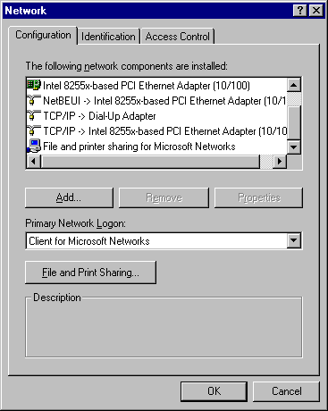File and Printer Sharing
Workstation Network Configuration

Client for Microsoft Networks and Dialup Adapter will be shown if you scroll up when viewing the actual screen.

Macs

Fleming’s In-house Graphics department is responsible for all advertising and graphics related projects.

The APPLE MACINTOSHs cannot directly access Windows Workstations across the Network (NTDOMAIN). They are connected to the NTDOMAIN via the Ian Mac Volume on the NTSERVER which has been set up on the Z:\ Partition of the SCSI Hard Disk 0, and may store up to 1.35 GB.

For example, a USER on the Windows 95/NT Workstation may copy files to the Ian Mac Volume on NTServer. Once the files are on the Ian Mac Volume, they can be removed by a MAC-USER through the same the Ian Mac Volume (from APPLE MACINTOSH’S: Using Chooser /NTDOMAIN/ Ian Mac Volume).

To be able to use the Ian Mac Volume the MacFile (on NTServer) must be started. (Note, this only needs to be done after NTserver has been restarted.)

To start the MAC server, select Start ⇒ Settings ⇒ Control Panel ⇒ MacFile then START.
If the MacFile is already running you will see a display of the MACServer status. The Ian Mac Volume is only accessible to members of the MAC Graphics group.

Internet and Email

ISP Settings
ISP Magna Data
Dial-up Phone No: 9923 0111 (9, for outside line)
DNS1 202.53.36.190
DNS2 203.4.212.10

User stats obtained from Magna Data home page are sent to our account whose email address is startrek@magna.com.au. All mail addressed to flemings.com.au is also delivered to this mailbox (though we hope no-one will ever do this). The email station grabs everything and separates it out into the individual recipients mailboxes; except for mail actually addressed to the account itself. This is the only mail the email station can't access. To download the stats you have to log in via modem rather than through the email station via the internet station. If you don't the stats (and anything else which has accidentally been sent there) will sit there for ever. Presently, the ISP kindly sends us the stats manually. We can access the stats directly if we wish but it’s generally too much trouble.

You can check if there is anything in the startrek mailbox by telneting into mail.magna.com.au on port 110. The following process works as of 8/5/01:
Open a telnet window (Start – Run – telnet)
Establish connection (open mail.magna.com.au 110) - should respond ‘+Ok Cubic circle’s…’
Enter the user name (user startrek) - should respond ‘+Ok startrek selected
Enter the password (pass spock) – should respond ‘+Ok Congratulations!’
List the number of outstanding email messages (list) – should show number of messages
Display the desired message number (retr 3) – should show whole email message
Delete the message (dele 3) – message will be deleted
Terminate the telnet connection (quit)

If, after initial connection, no characters echo back from the keyboard, enter the following:
set local_echo

Domain Name 1 flemings.com.au
Dial-up User Name startrek
Password spock
email account [anything]@flemings.com.au
Email Logon User Name startrek
Password spock

ZeeSweet and FNA email are single mailboxes in their own separate domains. mail@zeesweet.com.au and fruit@fna.com.au are downloaded from Magna Data once per day (this is a limitation of the email station)

The email is obtained by setting up a secondary ISP account in the email station for each mailbox. i.e. (fna@flemings.com.au is the primary account) and this account has a secondary account which picks up the mail sent to fruit@fna.com.au. No mail is expected to be sent to fna@flemings.com.au - that is just there to provide the primary account for the secondary account. This fuddle is necessary because the email station is designed for one domain only. We could have set it up so that any email sent to the fna domain could be picked up (e.g. ron@fna or graham@fna) by setting up a secondary account for each of them. This is not the problem though. There might be a tendency for people to address mail to “unknownjoebloggs@fna” without telling anyone and this would sit in the mailbox at Magna Data until it was manually downloaded and distributed.

Domain Name 2 zeesweet.com.au
Dial-up User Name zeesweet
Password zeesour
email account mail@zeesweet.com.au
Email Logon User Name zeesweet
Password zeesour

Domain Name 3 fna.com.au
FNA User Name fna1
FNA Password apple
email account fruit@fna.com.au
Email Logon User Name fna1
Password apple

Workstations with permission to access the Internet have shared access to the Internet via the Intel Internet Station router.

The Intel email Station functions as the email server and connects to our ISP via the Internet Station. It has been configured to dial up the ISP on the hour to send spooled mail from each workstation and retrieve mail from the “outside world”.

The current ISP for Flemings is Magna Data:

Contact: Sharron Foulcher
Phone. 9614 6646
Tech. Support 9272 9666
Dial-Up-Networking Phone No. 9923 0111
POP3 - mail.magna.com.au
SMTP - mail.magna.com.au
Proxy - cache.magna.com.au
PORT - 8080

NOTE: In the past when using the Netcomm Roadster 56K with Magna Data, we had to include the following string:

at + ms = 11, 1, 300, 33600

in the Modem Connection ⇒ Advanced page of Modem Setup (as shown below). This forced the Roadster to communicate using the V34 protocol at 33,600 Bps. This was because Magna Data didn’t have any 56K modems.
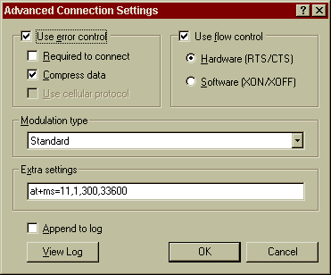

Currently, an “unsupported” 56K Modem Research “Companion” modem is being used through the Internet Station without the addition of this string and it seems to work okay though our line connection speed only ever goes up to about 28K. This is not a fault of the modem but of the line.

EMail Station clients can change their own passwords and have a small amount of control over their own accounts by going to Intel Email Station (IP = 192.168.42.253) I don’t think anyone ever has tried to go there alone at this stage!

Web Page

(Under Construction)

Adobe PageMill Ver. 2 for Macintosh has been used for Web Page development. Adobe SiteMill has also been utilized for Web file management. Please refer all queries about the Web site to the Fleming’s Web Master – Ian Ritchie.

Faxing

Fleming’s has one CANON fax machine a number of FAX modems (not used for faxing at time of writing).

Anti-virus

VET anti-virus software is loaded on each machine. It consists of a master installation in K:\Vetauto for Win95, Win98, NTWorkstation and Windows 2000. NTSERVER has a login script file which is executed for each machine each time it connects to the network. This is set up through 'USER MANAGER' on one of the domain controllers, the file it refers to is located in 'WINNT/REPL/IMPORT, as we can't guarantee which NT box the user will log into, this bat file must be placed on each server. (Look at fixing this using replication at some point). VET checks to see if it has the latest database engine and virus recognition files. If it doesn’t it automatically upgrades itself with the files from the master installation on the server.

Virus recognition update files are made available on the VET Website and are now upgraded almost daily.

Updating virus recognition files

ron@flemings.com.au is notified regularly of updated recognition files by email. Our Customer Number for VET is 146303. The user name is “wegen” (they allocated it – I didn’t choose it!)

To update the virus recognition files:

Download the update file into K:\vetauto\updates and execute it. It will update your own machine. Then in a DOS window run “c:\vet\update\setup /master” and follow the onscreen prompts. This will update the master installation files on K Drive. When machines log on next they will be automatically updated with the latest recognition files.

Updating VET database engine

When a new version of the VET database engine is released the update procedure is just a little different. Download the new engine but instead of executing the downloaded file you have to use Winzip to extract the files to your hard drive in a temp folder. Then you can run “c:\temp\setup /master” and upgrade the server files. Simply executing the downloaded file just upgrades your own system but doesn’t allow a master installation. (This is a bug in their program)

Backup

Cheyenne’s Arcserve for NT is the software which runs an automatic scheduled backup on the NTServer weekly.

Currently backed up:

E:\VOL2, F:\*.*, G:\MYOB, H:\USERS, and the Registry

Arcserve backs up to a Hewlett & Packard DAT 8E Tape drive that is located with the Ntserver, It can hold up to 8gig of information on 1 Tape.

* To ensure long life of tapes, rotate them between backups.

Security

Primary log-on for each workstation is as a client of Microsoft Networks. This passes the password to Windows login and you’re in! The password must be set in the server.

If the windows login is rejected then search for *.pwl files in Windows and delete the appropriate one and then relogin.

Tips and Tricks

Printer Drivers

There are two Genicom printer drivers which are used by various workstations. It was found that some computers would only print in certain programs if the older version 1.15 rather than 1.88 was loaded. Both are available in K:\Drivers\Genicom.

Finding the OS Product Key

“ProductKey.vbs” in Ron’s directory (visual basic script) will retrieve the Operating System product key from Win95 and Win98.

SQL Reporting

A Fleming’s SEASON is from 1st September to 31st August the next year
At the end of each season transactions are rolled over from Transaction to Trans_History, hence both tables may be required for reporting.
At the end of each season transactions are rolled over from Customer_Order to Cust_Order_History, hence both tables may be required for reporting.

Customer Order Tables

[Note: Conf_Amt (Confirmed Amount) etc refers to the number of items not the monetary value.]

To obtain the $ sales figures is a little tricky without a dedicated program. SQL will allow you to get close but not quite. You can use two methods. The first uses the Order and Order History tables from which it is a simple matter to extract the unit sales. These are then multiplied by Invoice_Tree_Price though, as my predecessor states below, this figure is not always recorded! The second uses the Transaction and Transaction History tables to obtain the dollar values but from these must be subtracted various amounts such as Royalties, Freight etc. Also, the Transaction Amounts do not take into consideration the occasional but unavoidable reality of customers returning trees. To subtract the credit that may be associated with a particular transaction is a whole other area fraught with complications!

The following was written by my esteemed predecessor and is amended only for stylistic purposes. It’s organized into pros and cons for each of the two methods outlined above.

Method 1) Order and Order History tables

Pros

Unit Sales may be obtained from Customer_Order and Cust_Order_History tables, referring to the Conf_Amt field (Confirmed Amount)

$ Sales are obtained simply by multiplying the above result with Invoice_Tree_Price to give total sales. The Invoiced_Flag must be set to ‘Y’. You can also obtain Year_of_Sale (SEASON), and Invoiced_Date to give a time indicator. Use (@MONTHBEG(Invoiced_Date) to allow sorting by month.

Cons

In some cases Invoice_Tree_Price was not recorded, and Conf_amt was zero whilst data was in Invoice_Tree_Price. This results in zero sales – thus the results may be inaccurate.

Method 2) Transaction Tables and Transaction History tables

$ Sales may be obtained from the above, or from Transaction and Trans_History tables. This data is not as easy to work with, however it offers a method of cross-checking, and it seems to be more accurate.

The Transaction amount is for the total of a transaction (i.e. Label charges, Freight, Royalties etc.) Hence we must subtract out all the charges in order to obtain sales relating directly to the sales of trees.

Pros

From Transactions we can obtain, Transaction_Type (INVOICE vs CREDIT) which allows us to give a more accurate ‘Total Sales’ figure as returned stock is taken into account.

We can obtain the Transaction_Date which we must turn into the correct SEASON by date comparisons.

Cons

We cannot obtain Unit data from Transactions and we have to manually calculate the season as we cannot access the Year_of_Sale (as we can in Order and Order History)

The SQL used to generate the Sales data from the Transaction tables follows:

SELECT DISTINCT (Customer_Master.Cust_No),',',
Cust_Name,',',
Transaction_Type,',',
Reference_Id,',',
Transaction_Date,',',
Transaction_Amount,',',
Label_charges,',',
Postal_Charges,',',
Rail_charges,',',
Freight_Charges,',',
Royalties

FROM
Customer_Master, Transaction

WHERE
Customer_Master.Cust_No = Transaction.Cust_No AND
(Transaction_Type = 'INVOICE' OR
Transaction_Type = 'CREDNOTE') AND Hist_Trans_Date >= '09/01/95' AND
Transaction_Date >= '09/01/95' AND
Transaction_Date <= '12/31/98' AND
Customer_Type = 'GCP' (or whatever)

UNION

SELECT DISTINCT(Customer_Master.Cust_No),',',
Cust_Name,',',
Hist_Trans_Type,',',
Hist_Reference_Id,',',
Hist_Trans_Date,',',
Hist_Trans_Amount,',',
Hist_Label_charges,',',
Hist_Postal_Charge,',',
Hist_Rail_charges,',',
Hist_Freight_Charg,',',
Royalties
FROM
Customer_Master, Trans_History
WHERE
Customer_Master.Cust_No = Trans_History.Cust_No AND
Hist_Trans_Date >= '09/01/95' AND
Hist_Trans_Date <= '12/31/98' AND
(Hist_Trans_Type = 'INVOICE' OR
Hist_Trans_Type = 'CREDNOTE') AND
Customer_Type = 'GCP'; (or whatever)

Using SQLTalk

SQLTalk needs some quirky little additions to the output to make it easier to use as a CSV file and import into Excel or ReportBuilder. This is due to there being “commas” in various output fields from the database such as the Name which are treated as field delimiters when we don’t want them to be. Therefore, extra comma fields are placed between each of the output fields and every output text field is surrounded by quotation marks(“ ”). It looks like this…

[The difference between single quotes and double quotes is a little difficult to tell because of the font etc but you’ll get the hang of it]

SELECT DISTINCT(CM.Cust_No), ',"',
CM.Cust_Name,'","',
CC.Contact_Title,'","',
CC.Contact_Given_Name,'","',
CC.Contact_Surname,'","',
CA.Address_1,'","',
CA.Address_2,'","',
CA.Suburb,'",',
CA.State,',',
CA.Postcode

There are three different “comma fields” (for want of a better term) that are used and they are found in the file NameTemplate.sql . They are Beginning, Continuing and End.

The Beginning comma field:
Usually, two OUTPUT fields are separated by a simple comma which doesn’t appear in the saved output. A normal comma field simply consists of the extra output field [,',',] The first [,] ends the previous field, the next [‘,’] is the actual comma field and the next [,] ends the comma field but ONLY IF THE NEXT FIELD IS NOT A TEXT FIELD.

The End comma field:
If the next field IS a text field then the comma field would look like this [,',"',] i.e. the first [,] ends the previous field, the next [‘,”’] is the actual comma field which contains the beginning quotation marks for the upcoming text field and the final [,] ends the comma field. If this is the only text field then the “comma field looks like this at the end [,'",', ] i.e. the first [,] ends the previous field, the next [‘”,’] is the actual comma field which contains the end quotation marks for the preceding text field and the final [,] ends the comma field.

The Continuing comma field:
If, however, there IS another text field following the first text field then the “comma field” looks like this [,'","',] i.e. the first [,] ends the previous field, the next [‘”,”’] is the actual comma field which contains the end quotation marks for the previous text field and the beginning quotation marks for the next text field and the final [,] which ends the comma field.

It’s all a bit painful but it makes life a little easier once you have the right output.

The next step is to import it into Word and remove all the TABS which SQLTalk puts between the output fields. (I hear you say, “Why don’t you just use the TABS as the delimiter?” However, nothing in Centura is ever quite that simple – try it and see).

I wrote a macro in Word which removes all the tabs and some of the other clutter. You then have to remove the header and footer rubbish manually to leave a beautiful CSV file which can be imported into Excel if you wish or used as a link file in ReportBuilder.

ReportBuilder v1.5 won’t allow linking the report to a CSV file so can’t be used for much. Therefore v1.1 is the program of “choice”.

There are a few idiosyncrasies with this program. It’s very buggy and doesn’t have a functioning “undo” command. It also dies quite often so save frequently.

Watering Database

Down in the watering shed there’s a computer with a program in it which controls the irrigation of the pots area. For reasons far too complex to enter into the database is called “water8.dbs” while the program that makes it all happen is called “water9.exe”. Don’t even think about it. It is also found on Graham’s machine.

Setup of the watering database:

- Install SQLbase onto a NT workstation machine, run Setup.exe from the K:\SQLBase directory, this will initiate the installation.
- Copy the watering database and its directory from K:\VOL2\Centura\Watering to C:\Centura
- Edit the SQL.ini file in the c:\centura directory, editing the DBDIR = “C:\centura” and the Database name to “Water8”.
- Add Water9.exe to the systems startup menu so the program executes at startup.
- Create a directory C:\Centura\WateringRegistry and copy the file Flemsys.ini from K:\Centura\FlemRegistrySettings to the new directory.
- From the K:\Centura\Felmdev directory run UpdateWaterRegistry.exe to allow the registry to be updated.

Auto Logon without prompting for a password:

- To enable this function you need to add several new values to the; [HKEY_LOCAL_MACHINE_SOFTWARE\Microsoft\WindowsNT\CurrentVersion\Winlogon]
- Add a new value of ‘DefaultUserName’ and set the data to the username you wish to auto log on as.
- Add the new value of ‘DefaultPassword’ and set this to be the password for the username above.
- Add a new value ‘DefaultDomainName’ and set this to the domain of the user.
- Add a new value of ‘AutoAdminLogon’ and set it either ‘1’ to enable auto logon or ‘0’ to disable.
- Exit and reboot, windows should not ask for a password and automatically show the desktop of that user.

- You can bypass the Auto Logon by holding the Shift-Key during the boot.

- WARNING: This means the password is stored in the registry, which means that anyone who has access to the machine has access to the password

The following information may be useful at this point though there is another manual especially written for this program.

File Name | Description
w_backup.bat | Backs up the water7 database from the hard drive to a floppy
w_restor.bat | Restores the database from a floppy
water7.dbs | The Watering Database
Waterbak.zip | The Backed-up Watering Database
Waterman.doc | The Watering Database Manual
PumpDiagram.pdf | Diagram of how the pumps are configured
WaterWire.pdf | The wiring diagram for the database –  how it connects to the pumps and solenoids etc.
Wzunzip.exe | The Windows unzip program
Wzzip.exe | The Windows zip program

Workshop Database

The is one PC in the Fleming’s Workshop It is their to assist the mechanics with the
servicing and maintenance of vehicles and equipment. It is runs a database named “Workshop” which allows the mechanics to track the service and maintenance records carried out on particular vehicle or piece of equipment.

Setup of the Workshop database:

- Install SQLbase onto an NT workstation machine, run Setup.exe from the K:\SQLBase directory, this will initiate the installation.
- Copy the workshop database and its directory from E:\VOL2\Centura\Workshop to C:\Centura.
- Edit the SQL.ini file in the c:\centura directory, editing the DBDIR = “C:\centura” and the Database name to “workshop”.
- Add Workshop.exe to the systems startup menu so the program executes at startup.
- Add printer drivers for the workshop printer: Epson LX 400, the PC will ask for the NT Workstation CD for the drivers, so keep it handy.

Auto Logon without prompting for a password:

- To enable this function you need to add several new values to the; [HKEY_LOCAL_MACHINE_SOFTWARE\Microsoft\WindowsNT\CurrentVersion\Winlogon]
- Add a new value of ‘DefaultUserName’ and set the data to the username you wish to auto log on as.
- Add the new value of ‘DefaultPassword’ and set this to be the password for the username above.
- Add a new value ‘DefaultDomainName’ and set this to the domain of the user.
- Add a new value of ‘AutoAdminLogon’ and set it either ‘1’ to enable auto logon or ‘0’ to disable.
- Exit and reboot, windows should not ask for a password and automatically show the desktop of that user.

- You can bypass the Auto Logon by holding the Shift-Key during the boot.

- WARNING: This means the password is stored in the registry, which means that anyone who has access to the machine has access to the password

